# British Library Web Portal - User Manual

## Home Page

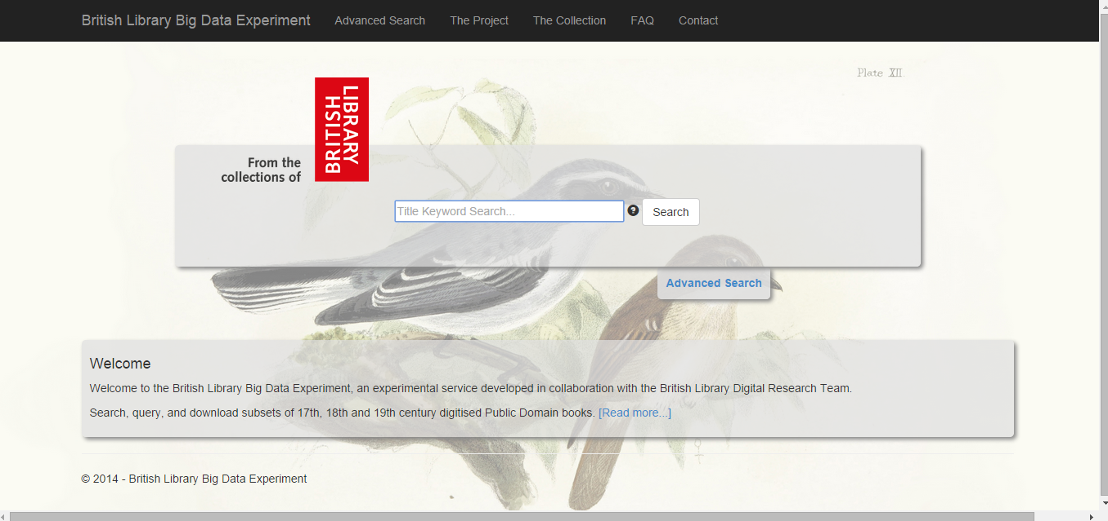

The user can access the Web Portal from the following link: http://blpublicdomain.azurewebsites.net/

At the Home page the user can perform a simple keyword search to search across all the fields apart from the OCR.

The user is able to search from a simple word or multiple keywords.

In the case that the user enters multiple keywords, results that match any of the input keywords are returned. In case a user enter a year, all the items about this specific year will be returned.

# Advanced Search Page

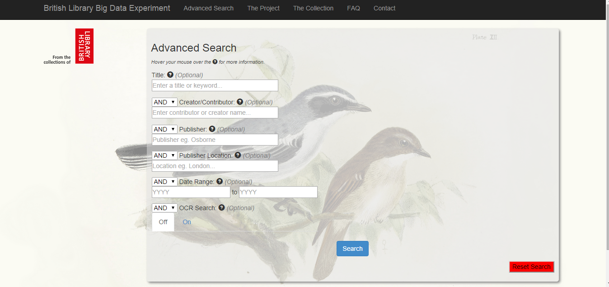

Access to the Advanced Search Page can be performed either directly using the URL

http://blpublicdomain.azurewebsites.net/AdvSearch/Index

or by clicking to the link "Advanced Search " at the Home Page.

At the AdvancedSearch page a user can perform more complicated queries using the boolean operators that can be applied on the fields.

**Example**

The user inputs the keyword "home" at the field title, selects the boolean operator "not" and then enters the keyword London at the field Publisher Location.

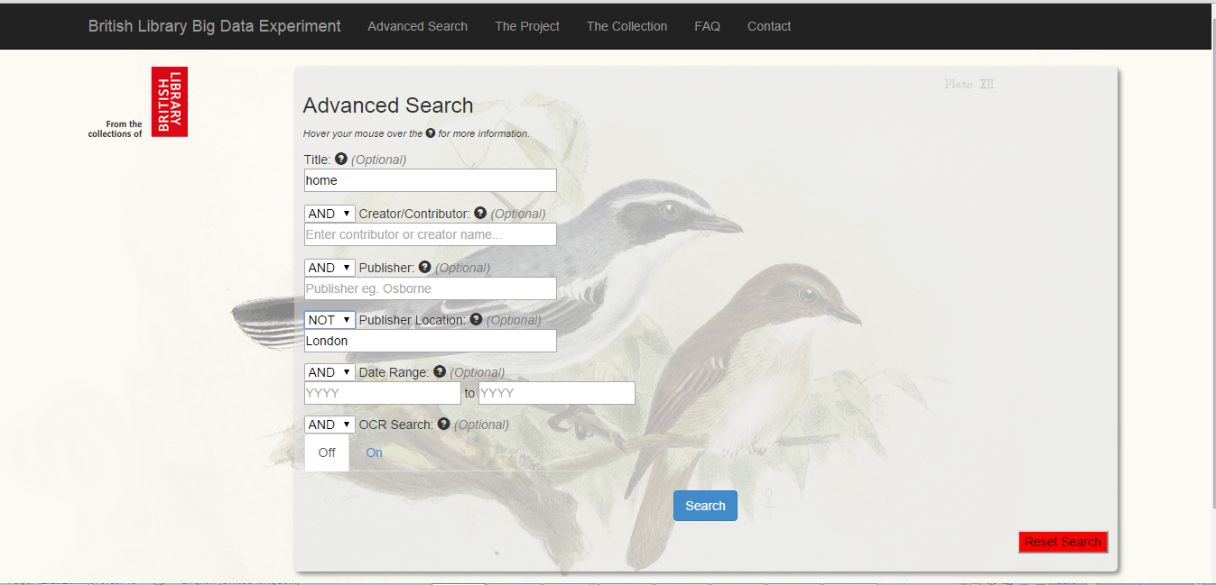

Then retrieves the appropriate results that include the keyword "home" at the title and does not have as publisher location the keyword "London."

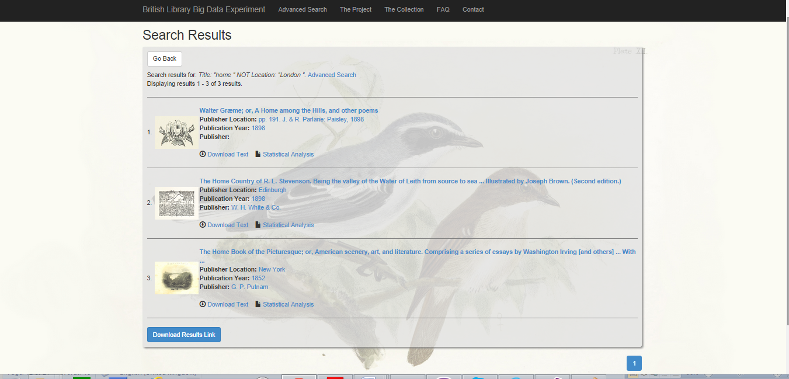

At the results page, when the user selects the Download Results Link , an internet shortcut is downloaded and the user is able to reproduce the queries.

In the case that user clicks at the link for the statistic analysis of an item the system retrieves the 20 most frequent words of the document and also the user has the ability to retrieve the frequency of a word, a bigram and a triagram.

In the case that the user clicks at the link "Download text" for an item at the Results Page, the ocr text and the corresponding xml are downloaded.

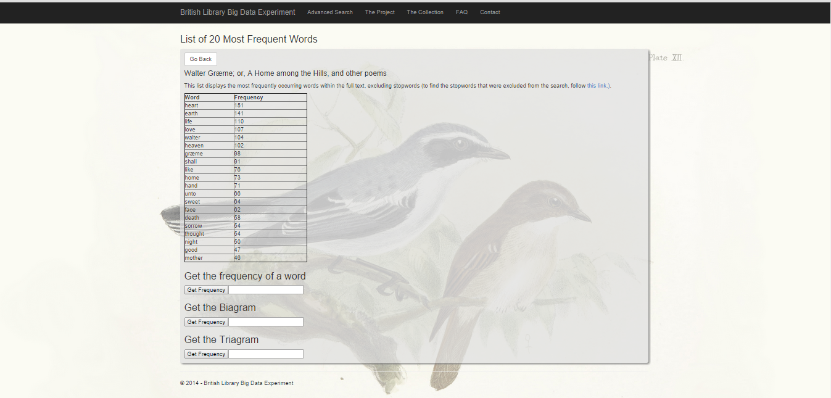

In order to open the zip file please install one of the following application

* WinRaR
* WinZip

